

**REPORT FOR Image Colour Detection**

As a project work for course

**PYTHON PROGRAMMING (INT 213)**

**Name**  : Shubham Jangir

**Registration Number** : 12108946

**Program**  : CSE B. TECH

**Semester** : Third

**School**  : School of computer

science and engineering

**Name of university** : Lovely Professional

University

**Date of submission** : 20th November 2021

**TABLE OF CONTENTS**

|  |  |
| --- | --- |
| 1. **ACKNOWLEDGMENT** | **3** |
| **2. ABOUT PROJECT** | **4** |
| **3.INTRODUCTION**  3.1 CONTEXT  3.2 IDEA | **5** |
| **4.LIBRARIES** | **6** |
| **5.IDE USED** | **7** |
| **6.SCREENSHOTS** | **8** |
| **7.System architecture** | **10** |
| **8. References** | **11** |

**ACKNOWLEDGMENT**

The satisfaction that accompanies the successful completion of any task would be incomplete without the mention of people whose ceaseless cooperation made it possible, whose constant guidance and encouragement crown all efforts with success.

I would like to take this opportunity to express my gratitude towards all the people who have in various ways, helped in the successful completion of my project. Many books are the result of a collection from various sources, such as internet, newspapers, magazines etc. Unfortunately, sources were not always noted or accurate acknowledgement.

Regardless, I am grateful to my friend, for his guidance, inspiration & constructive suggestions that helped me in the preparation & execution of this project.

**IMAGE COLOUR DETECTION**

A **Colour Detection in Python**, Colour detection is necessary to recognize objects, it is also used as a tool in various image editing and drawing apps. **Colour Detection Using Python**is the process of detecting the name of any colour. Well, for humans this is an extremely easy task but for computers, it is not straightforward. The Human eyes and brains work together to translate light into colour. Light receptors that are present in our eyes transmit the signal to the brain. Our brain then recognizes the colour. Since childhood, we have mapped certain lights with their colour names. We will be using the somewhat same strategy in **Image Colour Detection Using Python**.

In this **Colour Detection Python Project**, I build an application that can automatically detects the name of the colour and its RGB value by clicking on a particular area of the image

**INTRODUCTION: -**

**1.1 Context**

This project has been done as part of my course for the CSE(H) at Lovely Professional University. Supervised by Sagar Pande, I have two months to fulfil the requirements in order to succeed the module.

**1.2 Idea:** - The idea about that project came in my mind when I was reading a story in which a boy has colour blindness so I thought that this kind of software would be very beneficial for those people who have colour blindness as they don’t able to recognize some colours properly this kind of software may help them to recognize the correct colour and this kind of software can also be used in photo editing and Photoshop.

**LIBRARIES: -**

**OpenCV: - **

**OpenCV** is a huge open-source library for computer vision, machine learning, and image processing. OpenCV supports a wide variety of programming languages like Python, C++, Java, etc. It can process images and videos to identify objects, faces, or even the handwriting of a human. When it is integrated with various libraries, such as Numpy which is a highly optimized library for numerical operations, then the number of weapons increases in your Arsenal i.e. whatever operations one can do in Numpy can be combined with OpenCV.

**Pandas: -** 

Pandas is the most popular python library that is used for data analysis. We will provide highly optimized performance with back-end source code with the use of Pandas.

**IDE USED: -**

**PyCharm: - **

**PyCharm** is an integrated development environment (IDE) used in computer programming, specifically for the Python language. It is developed by the Czech company JetBrains (formerly known as IntelliJ). It provides code analysis, a graphical debugger, an integrated unit tester, integration with version control systems (VCSes), and supports web development with Django as well as data science with Anaconda.

PyCharm is cross-platform, with Windows, macOS and Linux versions. PyCharm provides an API so that developers can write their own plugins to extend PyCharm features. Several plugins from other JetBrains IDE also work with PyCharm. There are more than 1000 plugins which are compatible with PyCharm.

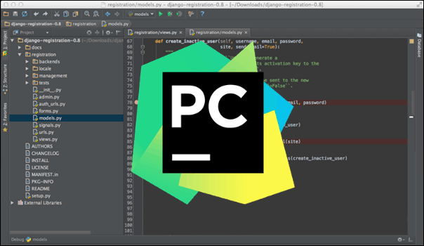

**SCREENSHOTS: -**

**Main page: -**

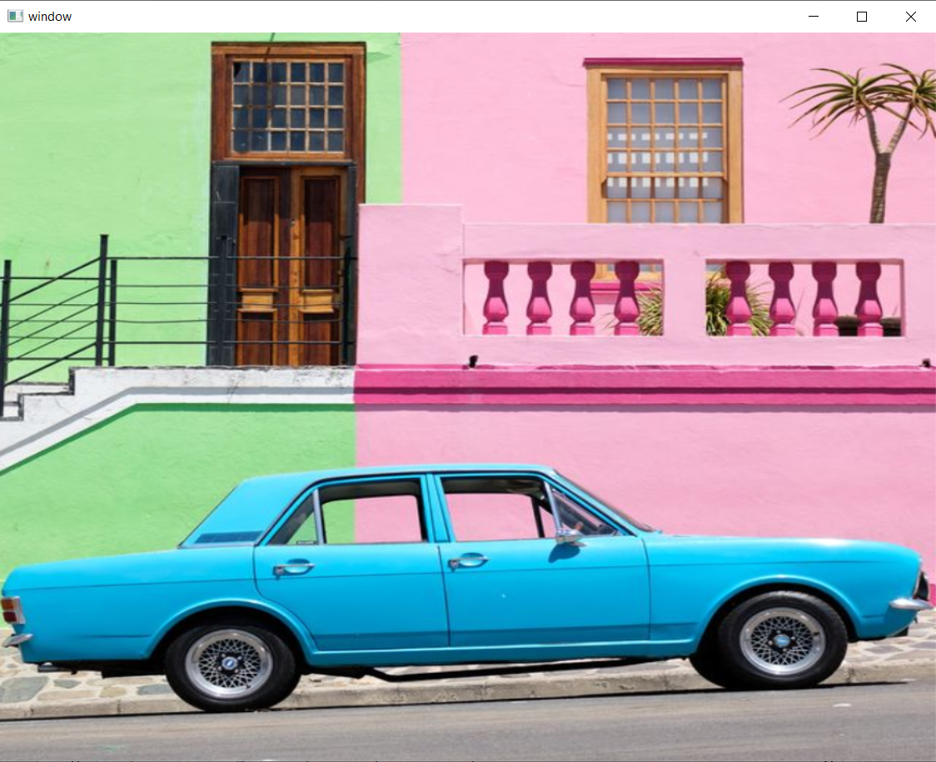

**OUTPUT: -**

After clicking on particular spot on image it detects and gives the colour name and RGB value of that particular area.

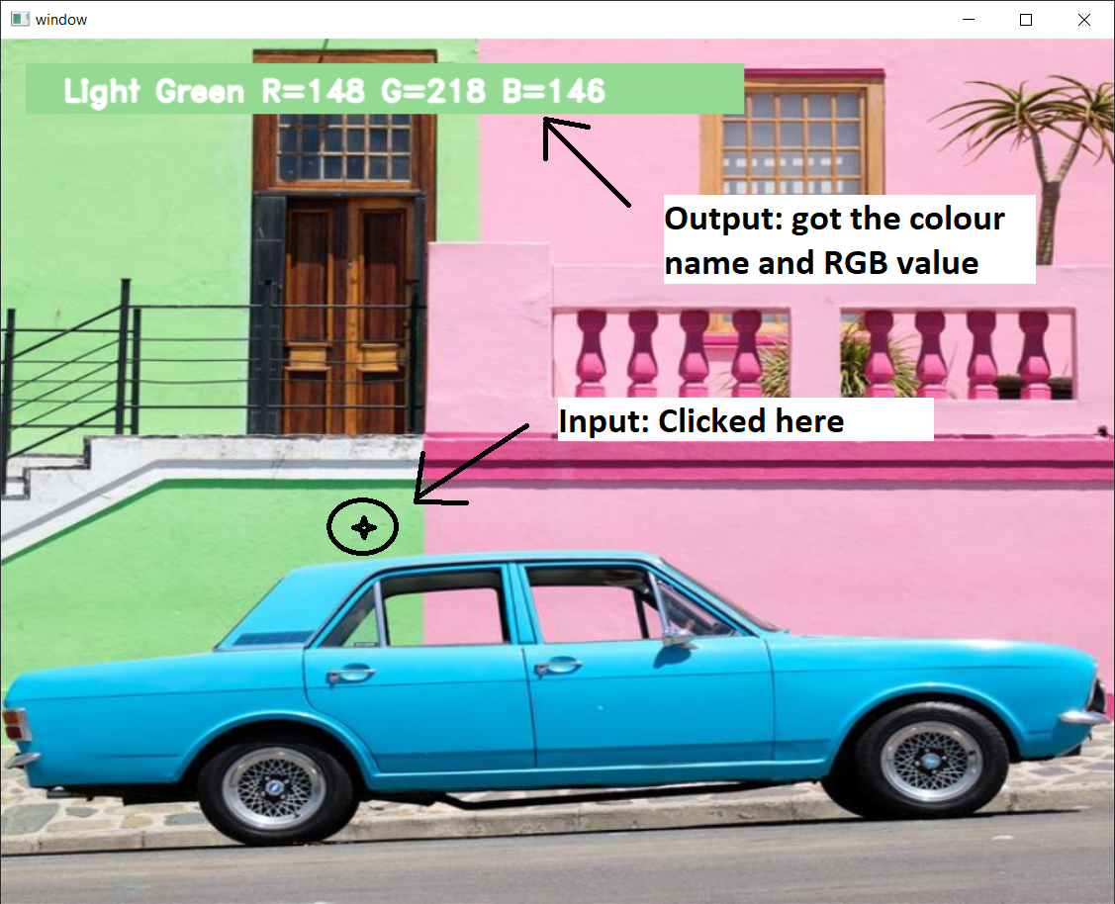

**System architecture:**

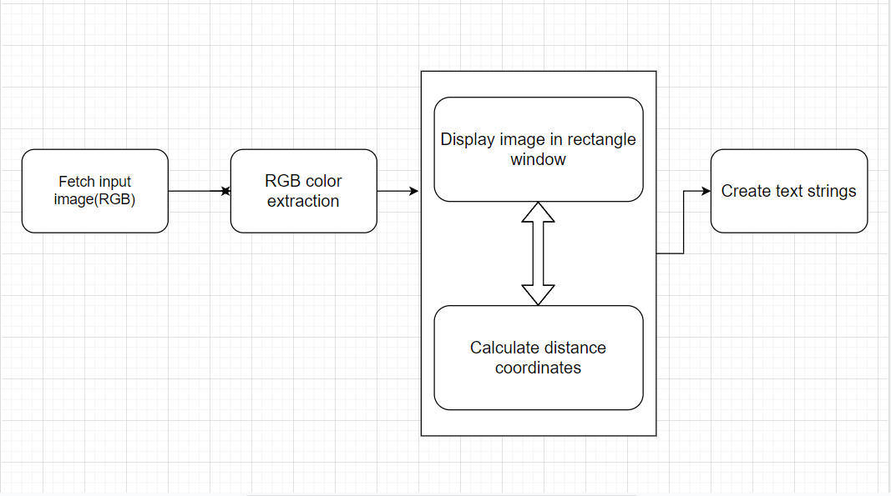

The above architecture shows the capability for the

project. It consists of a well-defined sequence diagram

that is abstracted from the source code. It leverages

the rich capabilities of the technology such as

OpenCv library in python.

The above architecture makes the process more

efficient based on principles and properties related to

each other. As we know that Red, Green and Blue are

the primary colours that can be mixed to produce

different colours. The present colour detection project

takes the path of an image as an input and looks for

the composition of three different colours red, green

and blue in the given image.

**References: -**

To conduct this project the following tools have been used:

* Pycharm IDE
* Pandas(library): http://pandas.pydata.org/
* Opencv(library): https://opencv.org/

I used these sides for my basis knowledge gain of the methods that will be used in the project

**1.1 GeeksforGeeks**

<https://www.geeksforgeeks.org/opencv-python-tutorial/#images>

**1.2 Nitratine**

<https://nitratine.net/blog/post/how-to-get-mouse-clicks-with-python/>

**THANK**

**YOU**